

Europass  Curriculum Vitae |  | /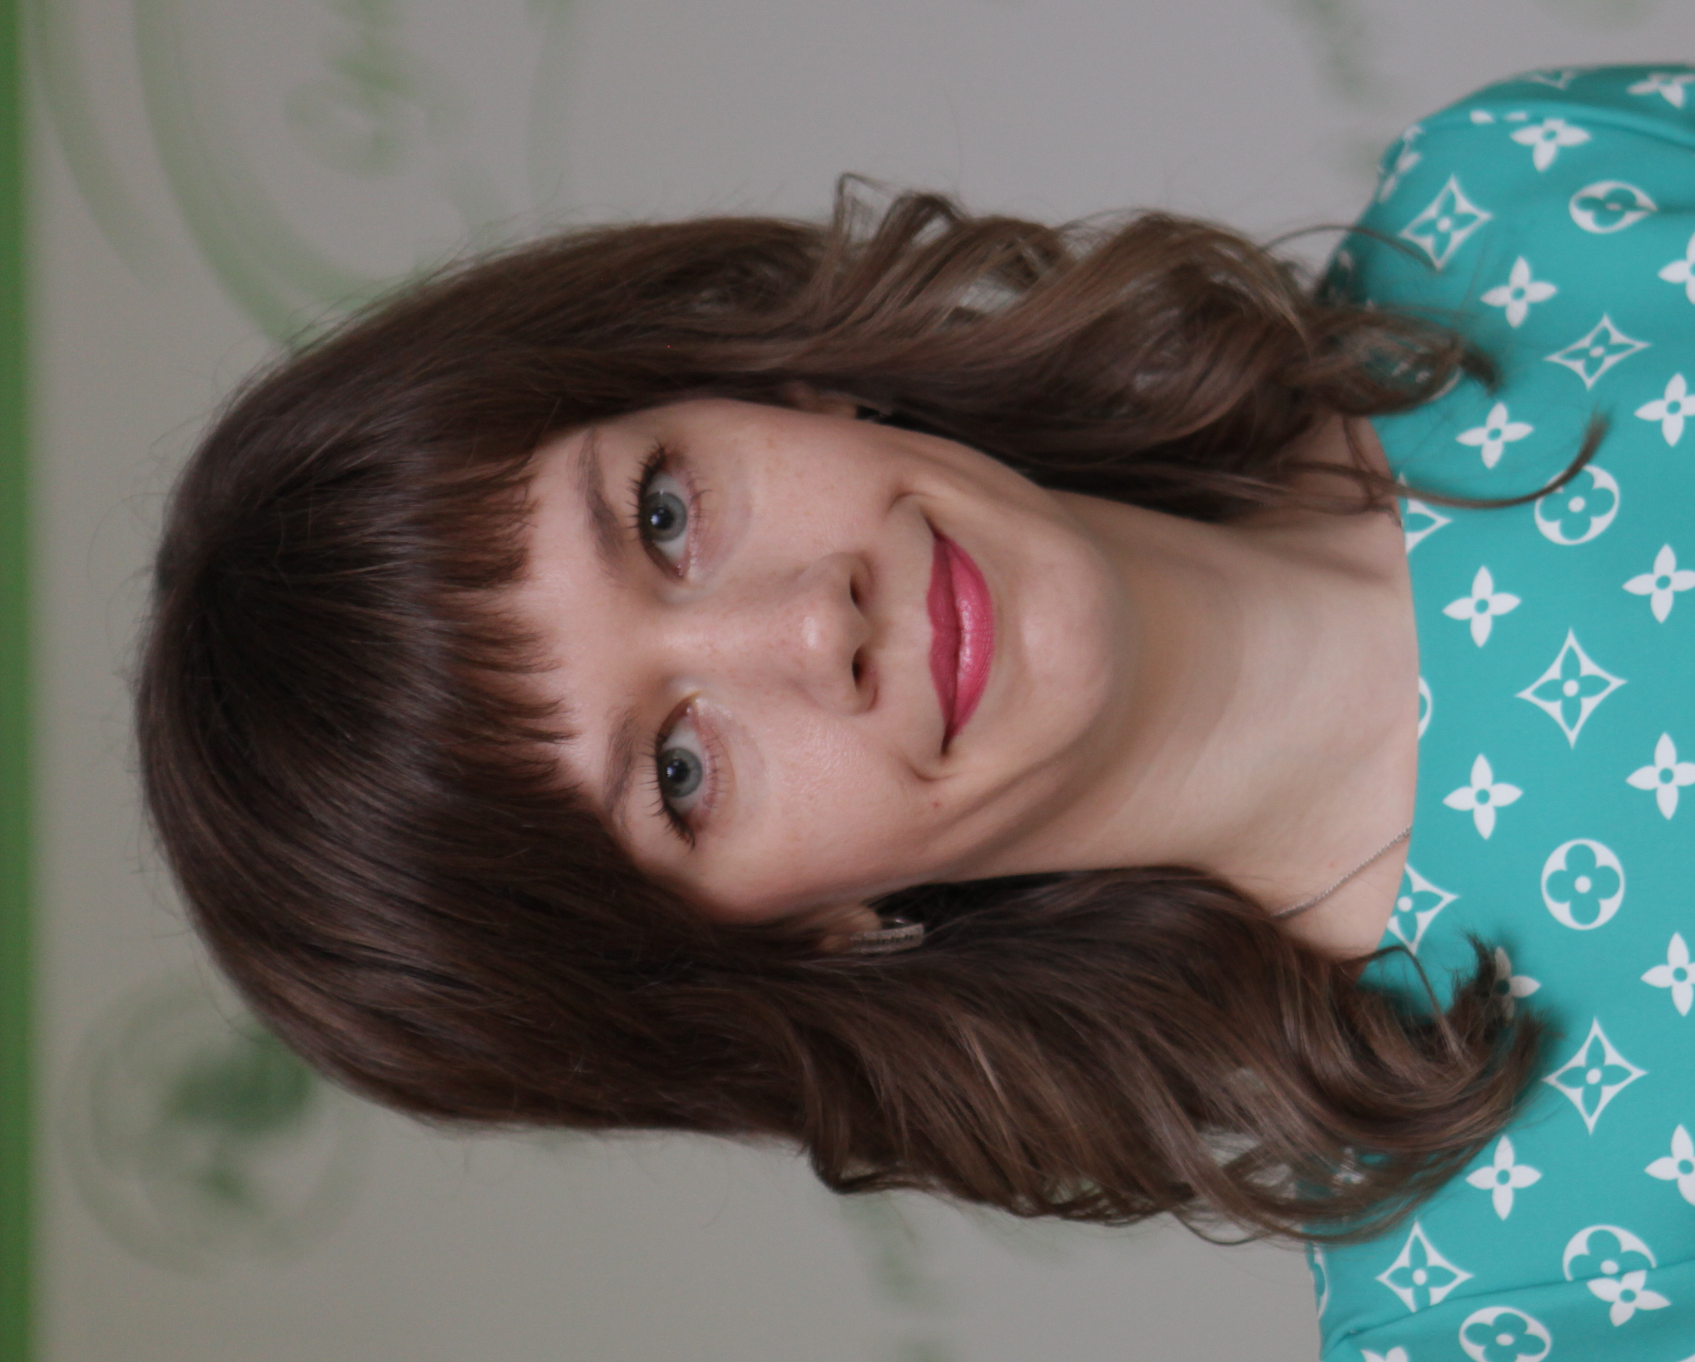
Personal information
First name(s) / Surname(s) |  | KATERYNA NEKYSLYKH
Address(es) |  | 45 Romana Atamaniuka Str., apt. 60, Sumy, 40031, Ukraine
Telephone(s) |  |  |  |  |  |  | Mobile: |  |  |  | + 38 066 8552454
Fax(es)
E-mail |  | Katrin_Sumy@i.ua
Nationality |  | Ukrainian
Date of birth |  | 30.07.1984
Gender |  | female
Current employment / Occupational field |  | Engineering-technological faculty, Sumy National Agrarian University/  PhD in Physics and Mathematics, Department of Higher Mathematics, Engineering and Technology Faculty, Sumy National Agrarian University
Work experience
Dates |  | 09.2012 till now
Occupation or position held |  | Associate Professor, Department of Higher Mathematics, Engineering and Technology Faculty at the Engineering and Technology Faculty
Main activities and responsibilities |  | Teaching and scientific activity in higher mathematics
Name and address of employer |  | Sumy National Agrarian University, 160 H. Kondratiev Str., Sumy, 40021, Ukraine
Type of business or sector |  | Higher Educational Institution (Agricultural Sector)
Education and training
Dates |  | 09.2001-06.2007
Title of qualification awarded |  | Master of teacher education, teacher of mathematics
Principal subjects/occupational skills covered |  | Higher mathematics
Name and type of organisation providing education and training |  | Sumy State Pedagogical University named after A.S. Makarenko, Ukraine
Level in national or international classification |  | Dipl. (University)
Dates |  | 2008-2011
Title of qualification awarded |  | Graduate school
Principal subjects/occupational skills covered |  | Mechanics of a deformed solid
Name and type of organisation providing education and training |  | Kyiv National Taras Shevchenko University, Ukraine
Level in national or international classification |  | PhD in Physics and Mathematics
Personal skills and competences |  | Reliability, loyalty, sociability, energy, purposefulness
Mother tongue(s) |  | Ukrainian
Other language(s) |  | English, Russian
Self-assessment |  |  | Understanding |  |  |  |  | Speaking |  |  |  |  | Writing
European level (*) |  |  | Listening |  | Reading |  |  | Spoken interaction |  | Spoken production
English |  |  | A1 | Basic User | A1 | Basic User |  | A1 | Basic User | A1 |  | Basic User | A1 | Basic User
Russian |  |  | C2 | Proficient user | C2 | Proficient user |  | C2 | Proficient user | C2 |  | Proficient user | C2 | Proficient user
 |  | (*) Common European Framework of Reference for Languages
Social skills and competences |  | I can and I am used to work in the team within the framework of international educational and scientific projects.
Organisational skills and competences
Computer skills and competences |  | Is fluent in computer. The competent with most programs.
Artistic skills and competences
Driving licence
Additional information:
Scientific Research Topic and Publications |  | - Nekyslykh K.M. Trends in improving the mathematical component of higher agricultural education. Innovative pedagogy, 2021. Issue 41. Volume 2. P. 72-76.  - Nekyslykh K.M. An integrated approach as a basis for the formation of professional competence of students of agricultural universities in the process of studying mathematical disciplines. Innovative pedagogy, 2021. Issue 32. Volume 1. P. 117-120.  - Nekyslykh K.M. Relationship between professional and applied orientation of teaching mathematics with the competence approach in the formation of professional competence of students of agricultural universities. Physical and Mathematical Education, 2020. Issue 3 (25). Part 1. P. 55-61.
Projects Experience:

Annexes

